Department of Computer Science and Engineering
Lab Report
Lab Report No | : | 02
Lab Report Name | : | Bisection Method
Course Title | : | Numerical Methods Sessional
Course Code | : | CSE 226
Name | : | Fahim Faisal Pathan
ID | : | 1119033
Level | : | 2 | Term | : | 2 | Section | : | A | Group | : | G2
Date of Submission | : | 28/04/2026 | Semester | : | Spring | Year | : | 2026

Marking Rubric
Problem Understanding & Report Clarity (3) | Implementation (4) | Results, Analysis & Presentation (3) | Total(10)

Key Learning:
- Root Location: It utilizes the Intermediate Value Theorem by requiring that and have opposite signs to guarantee a root exists within the chosen interval.
- Interval Halving: The algorithm systematically narrows the search area by calculating the midpoint in each of the 15 iterations.
- Boundary Selection: It updates the interval by checking if the root lies in the left or right half based on whether.
- Transcendental Solution: This numerical approach is specifically used because the function cannot be solved for using standard algebraic isolation.
- Guaranteed Convergence: While slower than other methods like Newton-Raphson, the Bisection method is highly robust and is guaranteed to converge as long as the initial interval is valid

Code Implementations:

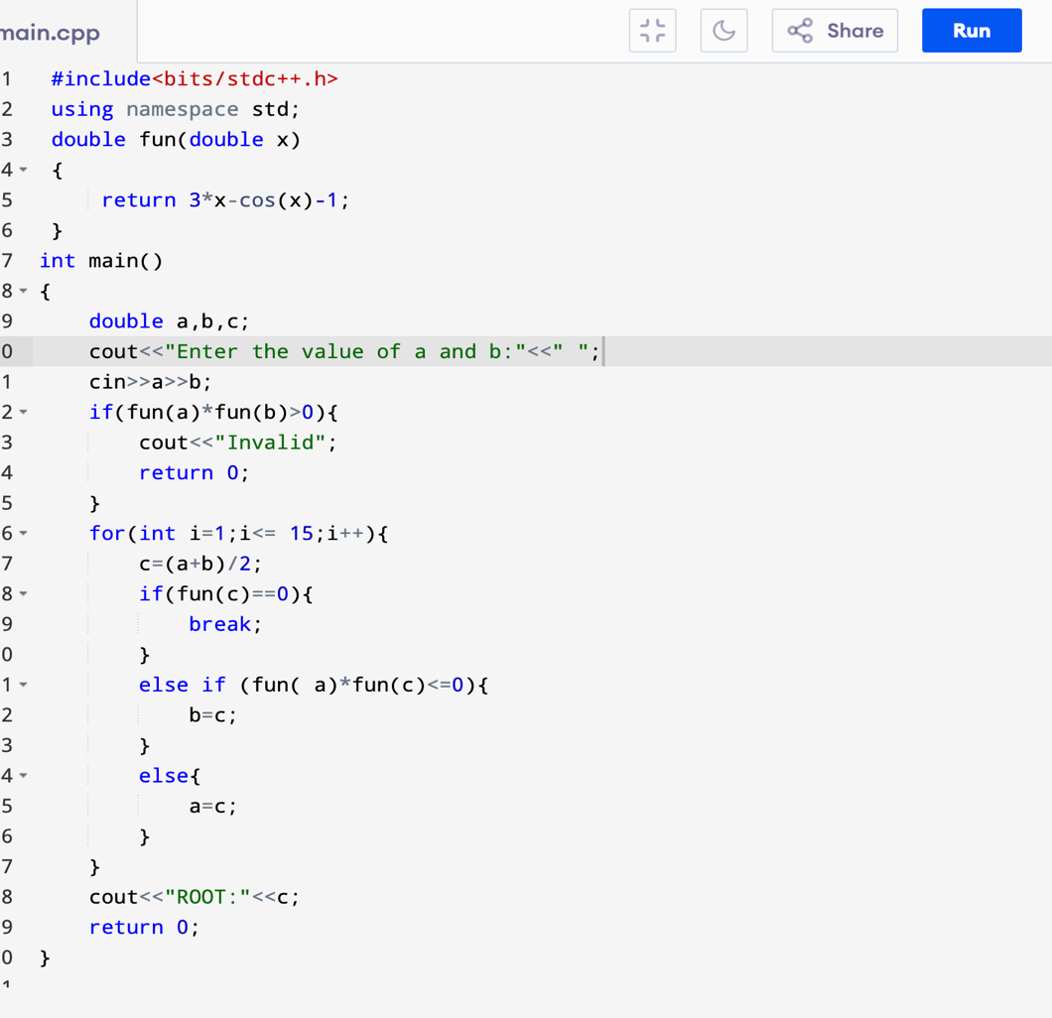

Code 2:

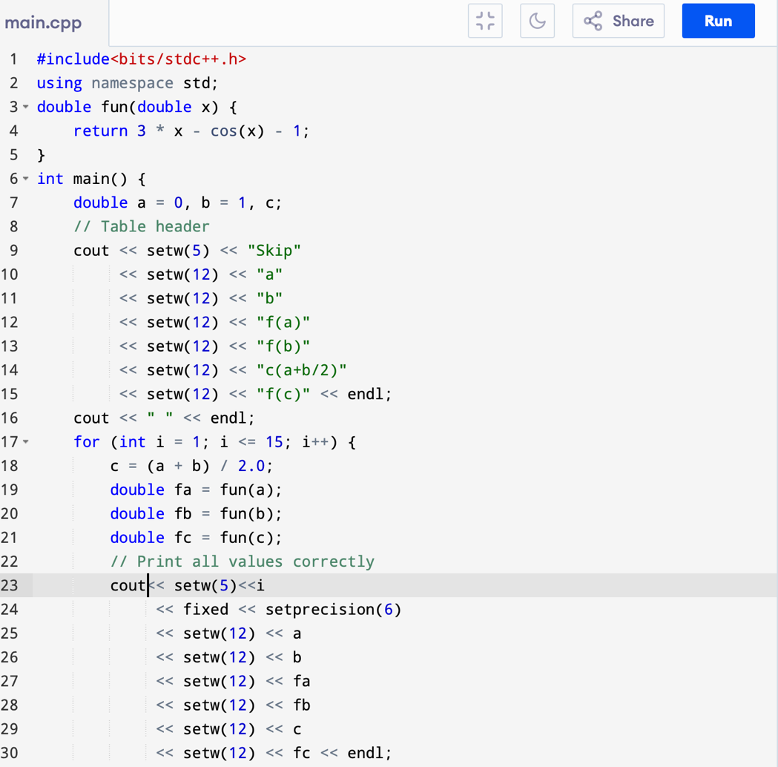

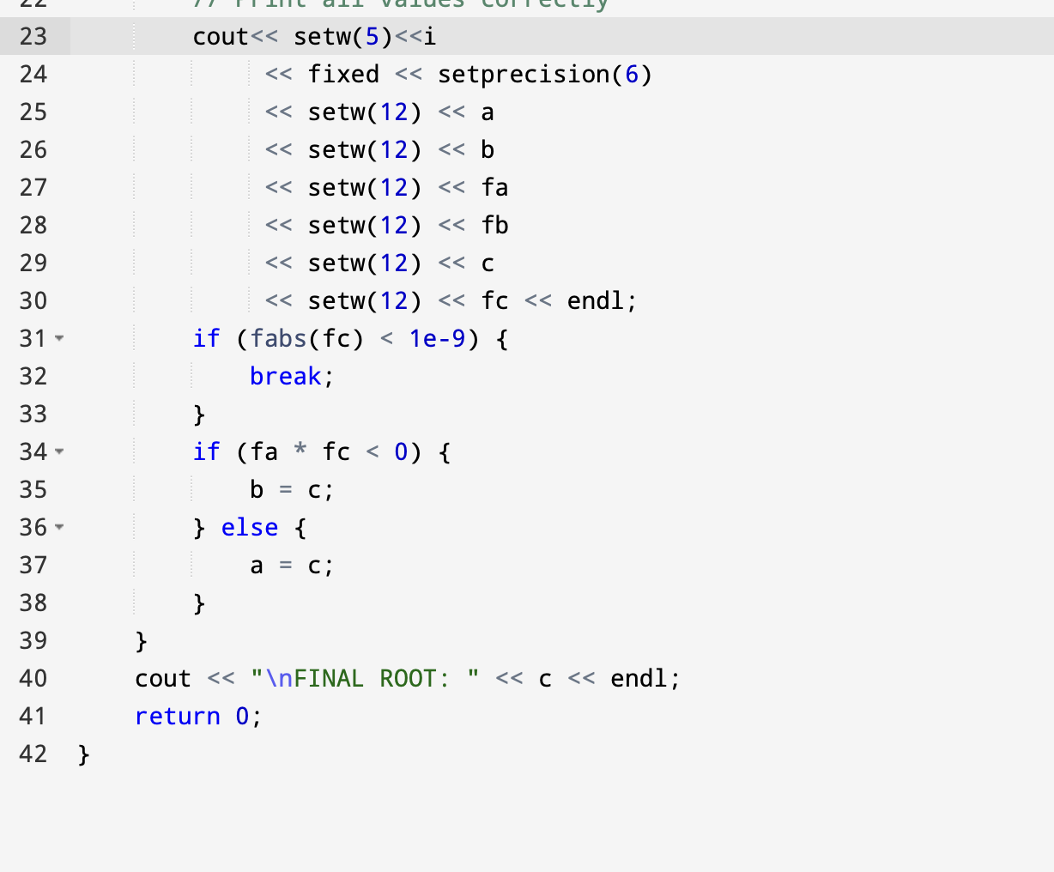

Sample Input, Output, and Result Analysis:

Input Sample: a= 0 and b= 1

Output Sample: 0.607086

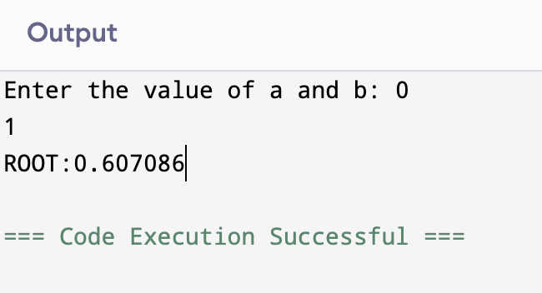
Output 2:

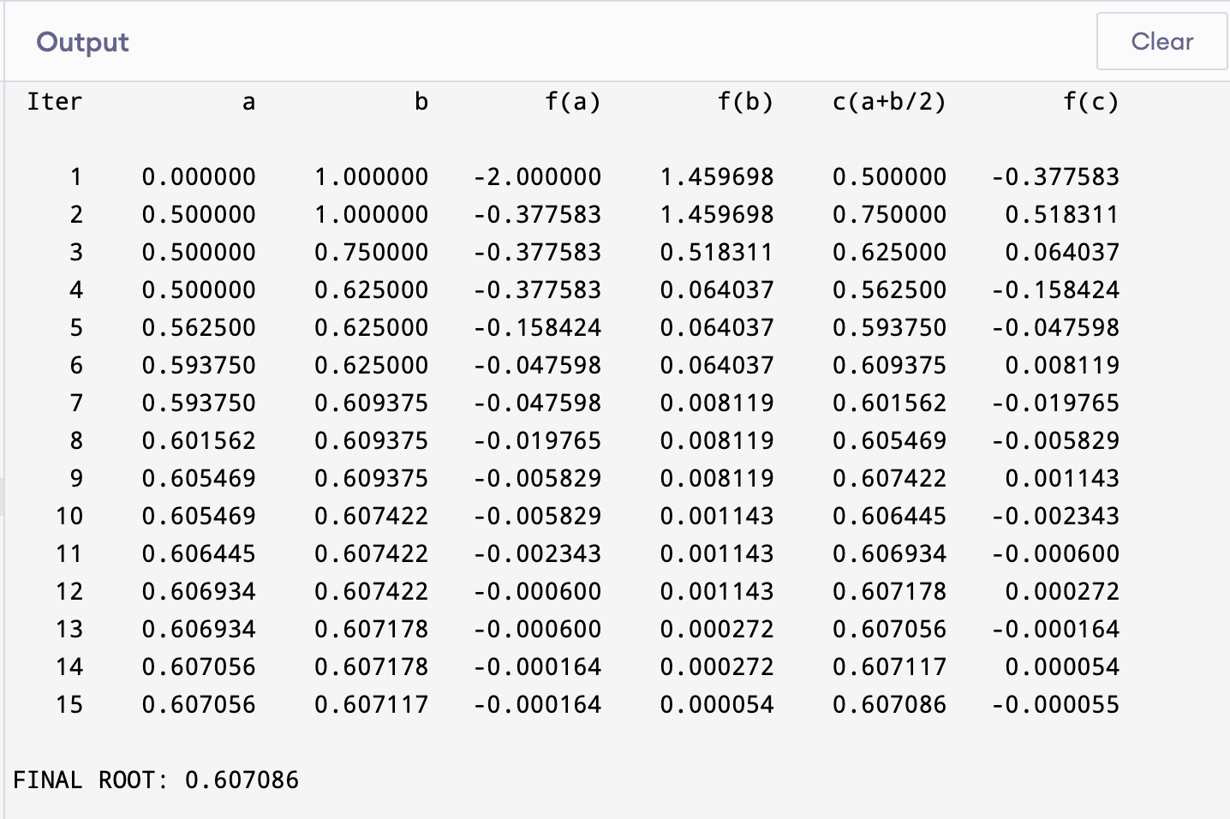

Result Analysis
• Root Existence: A root exists between 0 and 1 because is negative and is positive.
• Accuracy: 15 iterations provide a precision of approximately if the initial interval width is 1.
• Estimated Result: For the range, the program will converge on a root of approximately 0.6071.
• Monotonicity: The function is strictly increasing, ensuring the method converges to a single, unique solution.
• Validation: The "Invalid" check correctly prevents the algorithm from running on intervals that do not contain a sign change.

